DOWNLOAD OUR PROJECT ZIP

EXTRACT

OPEN NETBEANS

OPEN OUR PROJECT FOLDER

GO TO THE GROUPPROJECT JAVA FILE WITH THE MAIN METHOD

CLICK RUN

After starting the main class

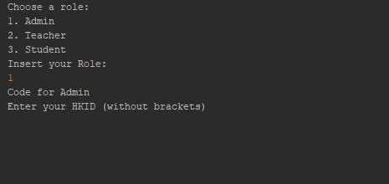

Select the role following the terminal and inputting the correct number

The login information can be found in the user.java class. Remember to pick the correct login according to the role you would like to access.

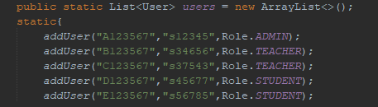

After successfully logging in. Read the information on the terminal and input your response accordingly.

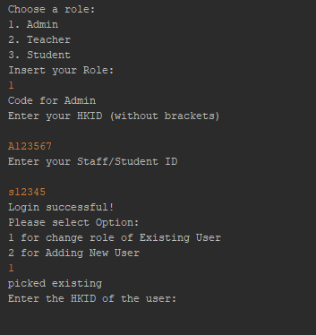

The process is very similar for different roles.